**White Blood Cell Segmentation**

**Model Overview**

* **Model Used:** Custom U-Net
* **Backbone:** U-Net
* **Layers:** Convolutional, Batch Normalization, ReLU, MaxPooling, Upsampling

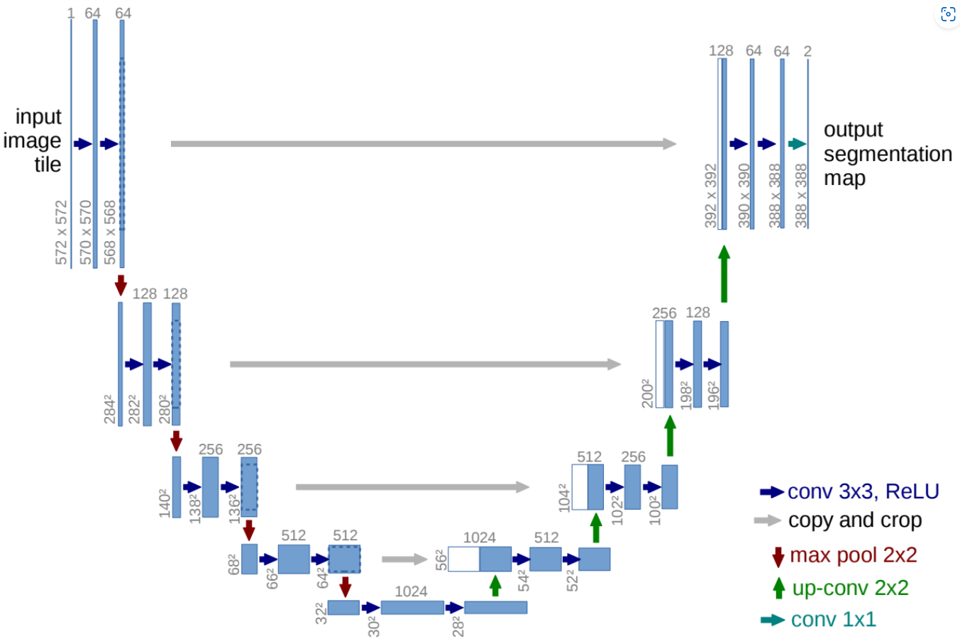

**Training Details**

* **Optimizer:** Adam (learning rate: 1e-4)
* **Loss Function:** Binary Focal Loss (gamma=2)
* **Epochs:** 60
* **Training Data:** 50 image and mask samples
* **Testing Data:** Separate unseen blood cell images
* **Preprocessing Steps:**
  + Image resizing to 256x256
  + Normalization (scaling pixel values)
  + Grayscale conversion

**Model Performance**

* **Evaluation Metric:** Jaccard Coefficient
* **Model Accuracy: 80%**
* **Losses:** 1.2

**Model Loss plot**

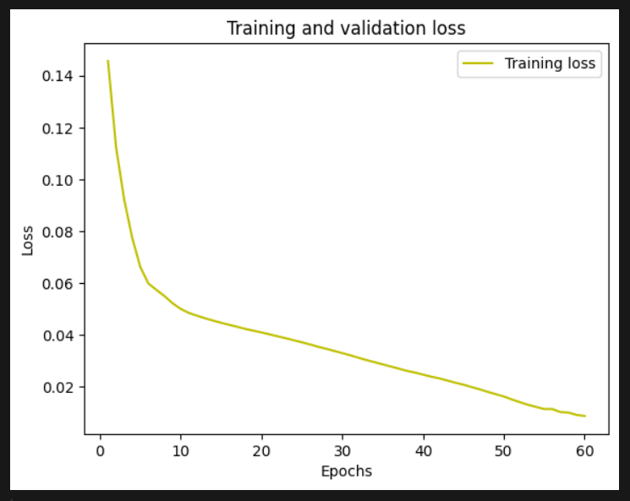

**Result**

